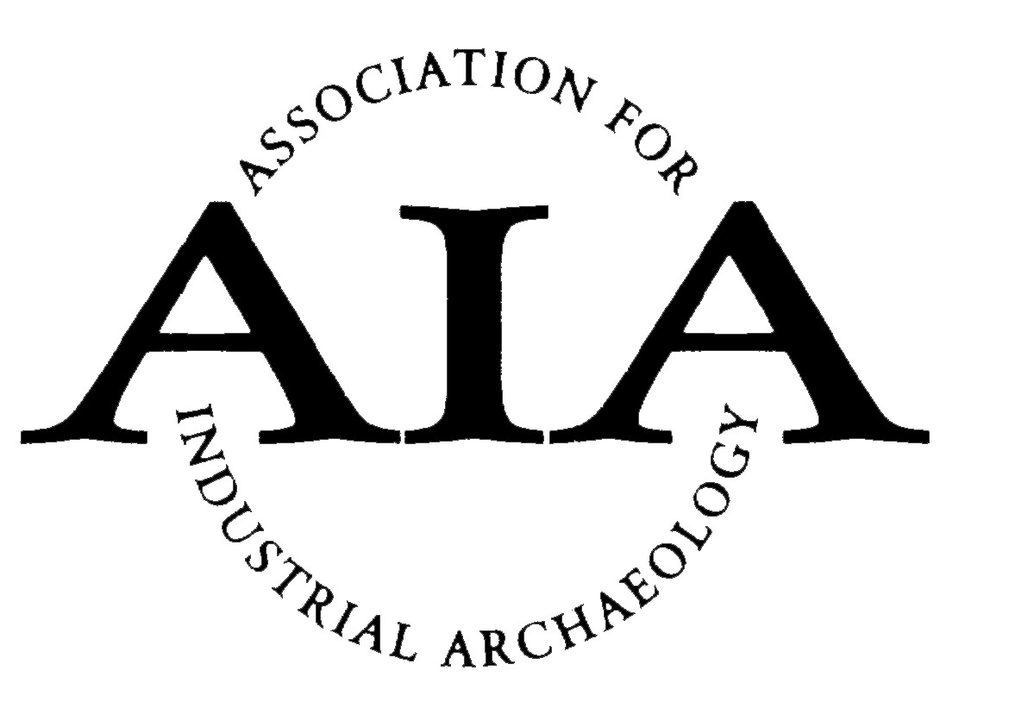 | The Association for Industrial Archaeology  Publications Awards Entry Form
Important: This form should only be completed after reading the relevant Awards Rules and Criteria.

Send it to The Secretary, Association for Industrial Archaeology, 2, Wesley Court, Duke Street, Broseley, Shropshire TF12 5LS, or by email to secretary@industrial-archaeology.org by 31st January.

Name:
Address:
Telephone: | Email:
Signature: | Date of application:

Award Checklists
Please add the appropriate information/enclosures requested below:

Publications Award

Category applied for: Voluntary Society: □ National Organisation or Publisher □
Name of Organisation: . . . . . . . . . . . . . . . . . . . . . . . . . . . . . . . . . . . . . . . . . . . . . . . . . . . . . . . . . . . . . .

Title of publication: . . . . . . . . . . . . . . . . . . . . . . . . . . . . . . . . . . . . . . . . . . . . . . . . . . . . . . . . . . . . . . . . .

Date of publication: . . . . . . . . . . . . . . . . . . . . . . . . . . . . . . . . . . . . . . . . . . . . . . . . . . . . . . . . . . . . . . . .

