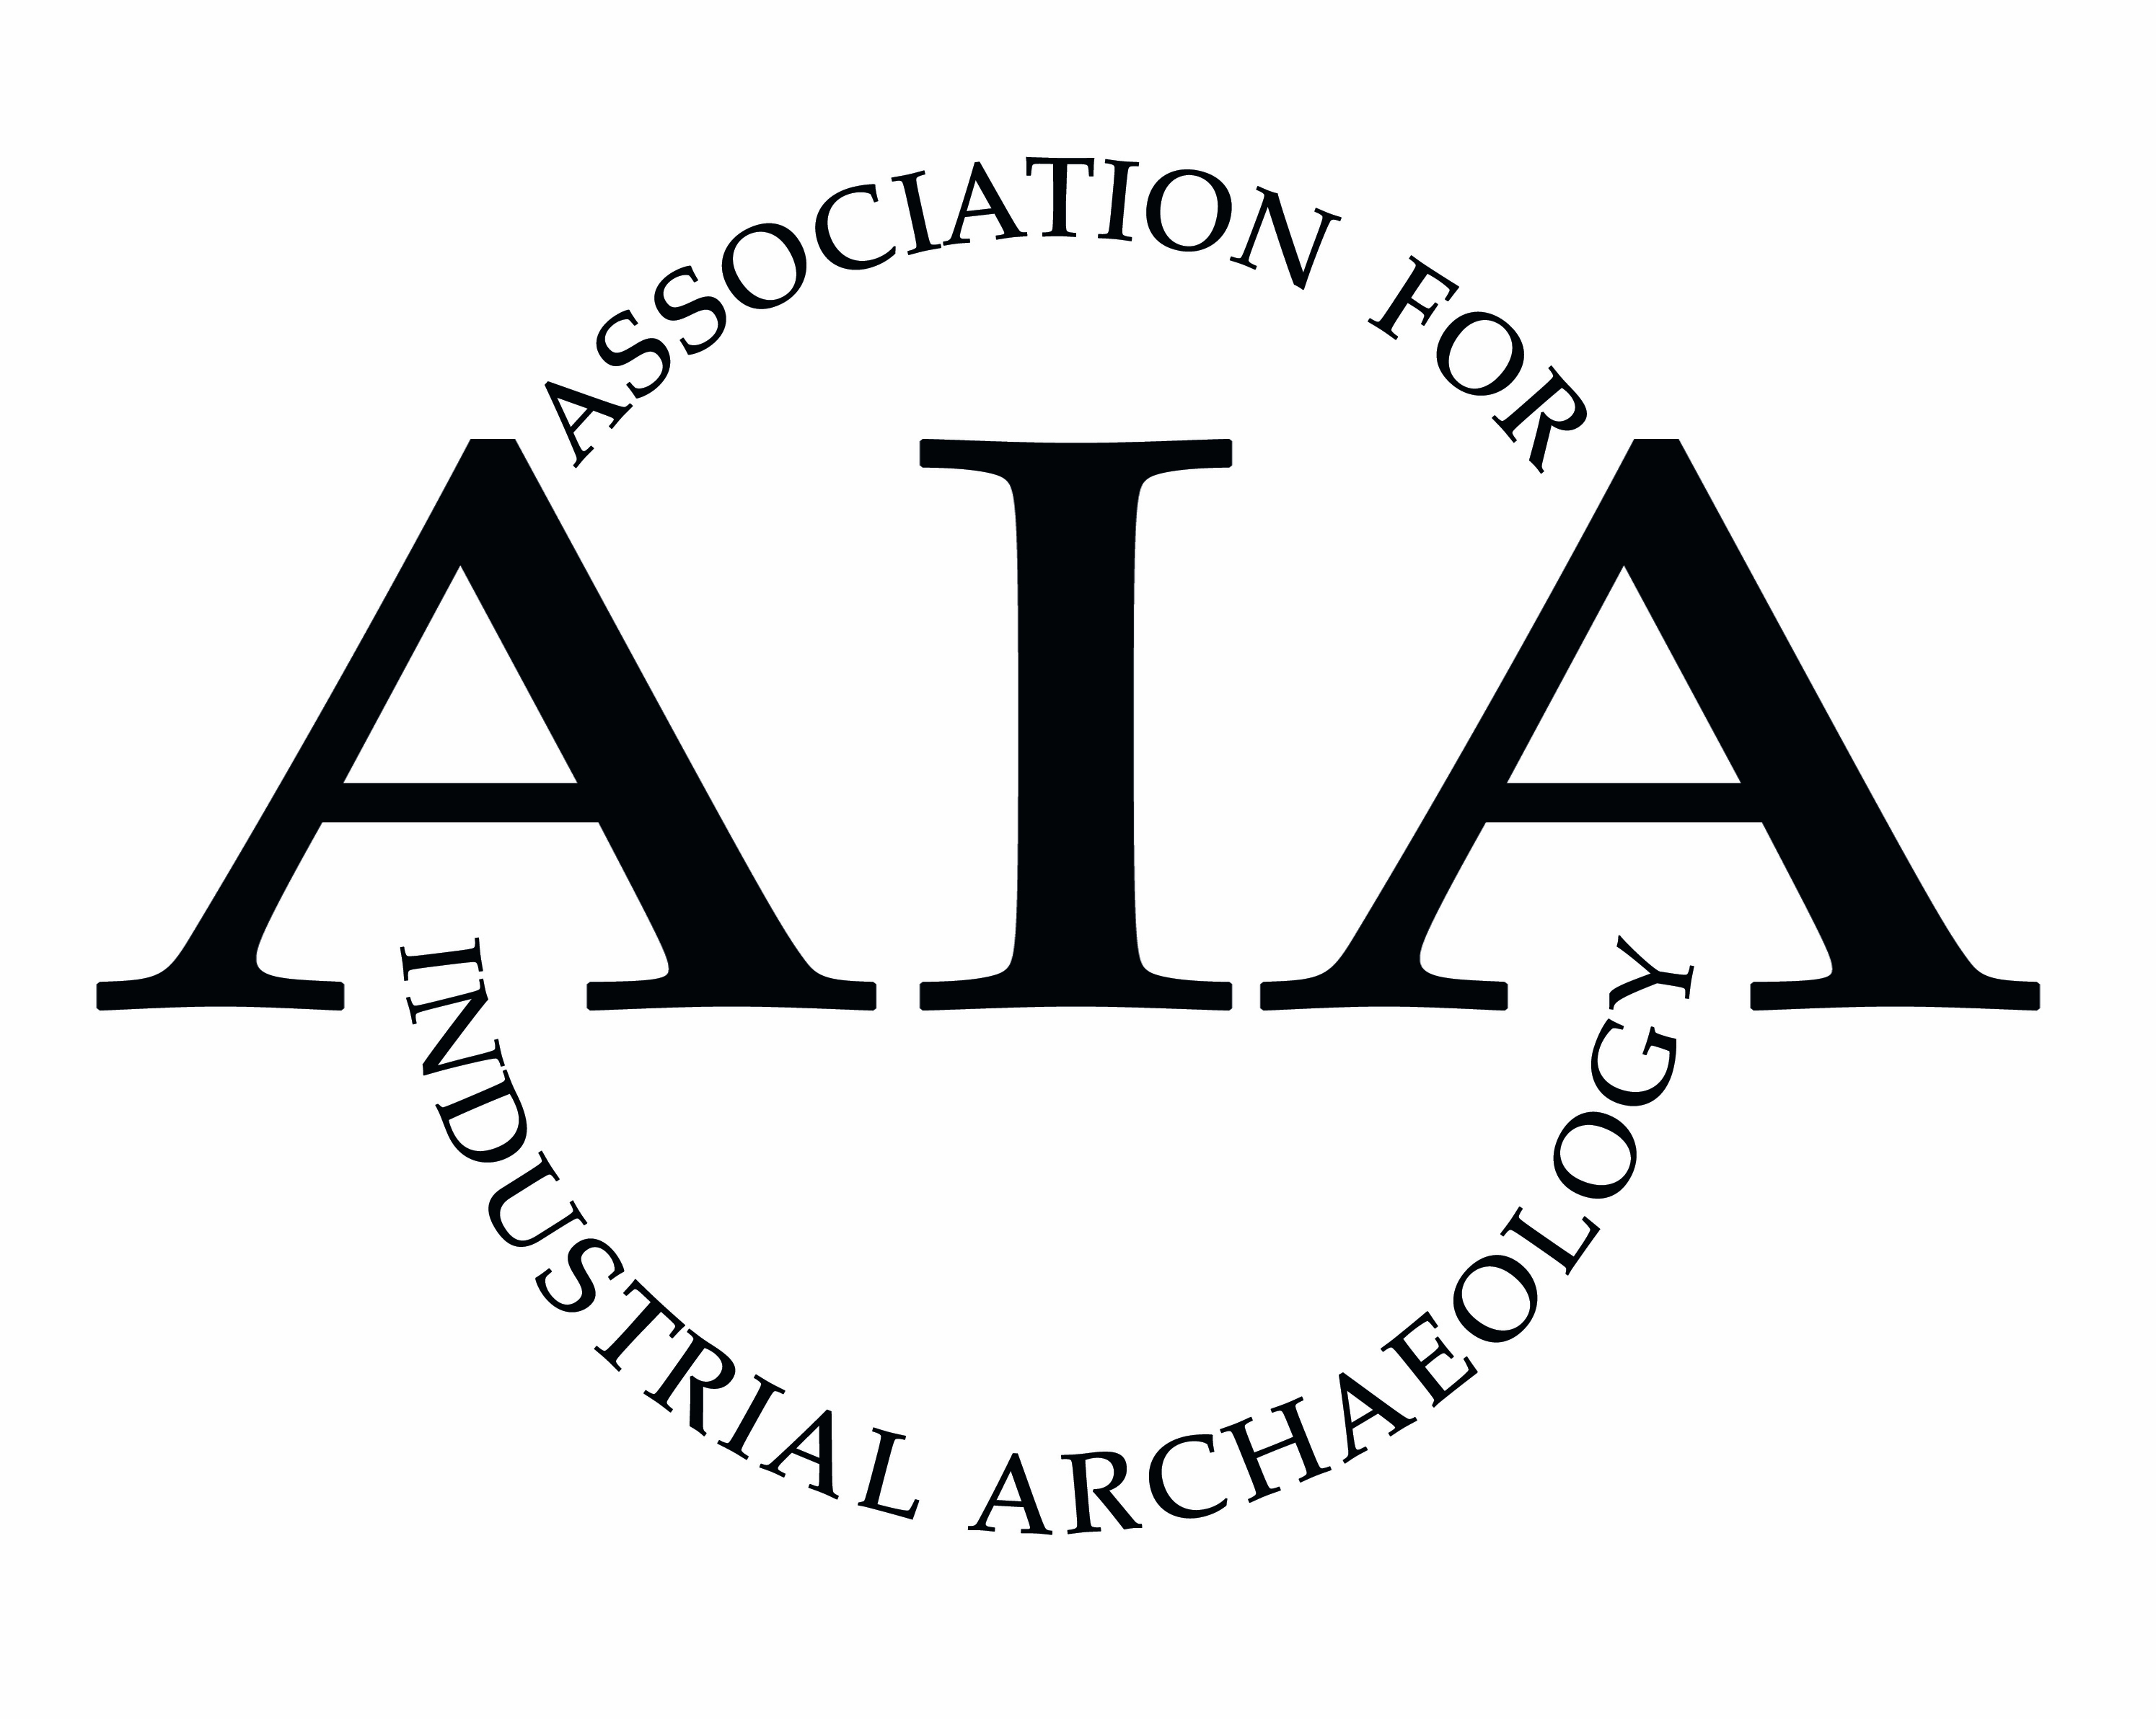

**Association for Industrial Archaeology**

**Publications Awards**

The aim of these awards is to encourage high standards in the publication of research and recording in industrial archaeology, but excluding works solely concerned with transport or business history. Three awards can be made each year. Nominations for this award may be submitted by any member of AIA or one of its Affiliated Societies. Entries should have been published within the last two years, but the judges reserve the right to consider publications outside this time window in exceptional circumstances, such as publications from overseas.

There are two categories. The deadline each year is **31st January**.

Publications by Local Voluntary Societies, defined as those in the United Kingdom essentially run by volunteers and concerned with a particular location or type of site. Publications submitted may be newsletters, journals or occasional publications.

Publications by National Organisations. These may include publications by statutory bodies such as Historic England or Historic Environment Scotland, or national voluntary groups such as the Victorian Society or the Railway & Canal Historical Society. Commercial publishers are also eligible to submit entries.

* Applications should be made using the Awards Entry Form and posted to reach the AIA Hon Secretary, Ian West, by **31st January** for consideration for that year’s awards. Entry forms must be accompanied by a copy of the work being nominated. Email [secretary@industrial-archaeology.org](mailto:secretary@industrial-archaeology.org) Post to AIA Secretary, 2, Wesley Court, Duke Street, Broseley, Shropshire TF12 5LS.
* No person who has written, or made a significant contribution to, a particular work can nominate or judge it.
* Three judges for the award will be appointed by AIA Council; for the Voluntary Societies Award these will include the Editor of *IA News* and the Affiliated Societies Liaison Officer. A simple majority is required for their decisions.
* Judging criteria will include academic quality, readability, attractive layout and style and the quality of illustrations (photographs and diagrams) where these are included.
* The prize will be a cheque for £200.
* The winner(s) will be invited to the AIA’s Annual Conference to receive the award. Details of winning entries will be published in *IA News* and a list of all winners will be maintained on the AIA web site.
* Should the judges consider that a nomination does not meet the criteria for these awards, the AIA reserves the right to submit it for one of its other awards.

Publication Awards, 2025