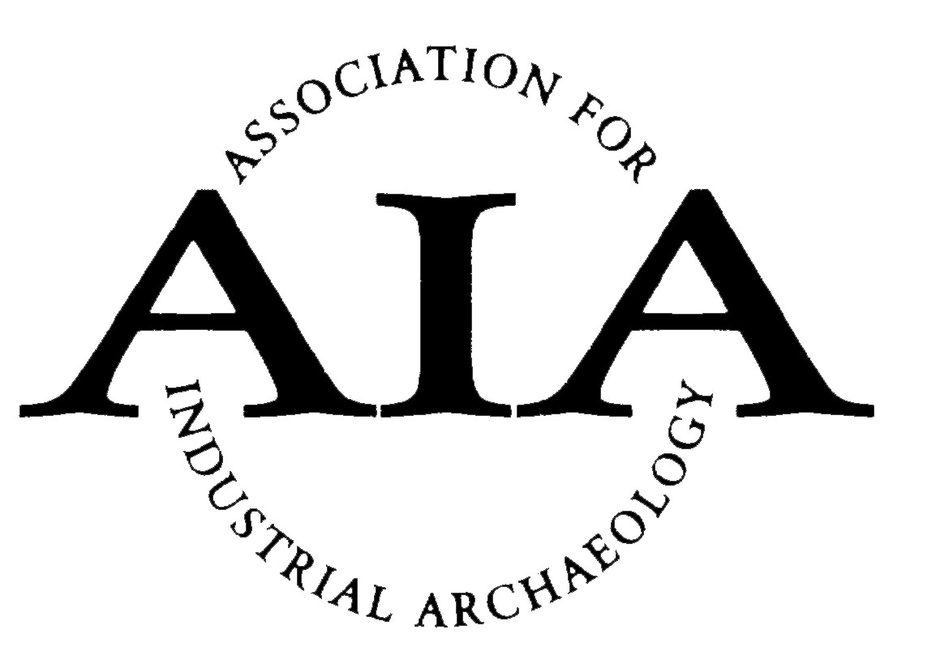 | The Association for Industrial Archaeology  Awards Entry Form
Important: This form should only be completed after reading the relevant Awards Rules and Criteria.

Send it to The Secretary, Association for Industrial Archaeology, 7 St Michael’s Close, Madeley, Telford, Shropshire TF7 5SD, or by email to secretary@industrial-archeology.org by 31st January.
Please indicate which Award you are applying for:
Publication: □ Archaeological Report: □ Dorothea Award: □
Name:
Address:
Telephone: | Email:
Signature: | Date of application:

Award Checklists
Please add the appropriate information/enclosures requested below:

Publications Award
Category applied for: Voluntary Society: □ National Organisation or Publisher □
Name of Organisation: . . . . . . . . . . . . . . . . . . . . . . . . . . . . . . . . . . . . . . . . . . . . . . . . . . . . . . . . . . . . . .
Title of publication: . . . . . . . . . . . . . . . . . . . . . . . . . . . . . . . . . . . . . . . . . . . . . . . . . . . . . . . . . . . . . . . . .
Date of publication: . . . . . . . . . . . . . . . . . . . . . . . . . . . . . . . . . . . . . . . . . . . . . . . . . . . . . . . . . . . . . . . .
Confirm copy enclosed: □

Archaeological Report Award
Title of Project: . . . . . . . . . . . . . . . . . . . . . . . . . . . . . . . . . . . . . . . . . . . . . . . . . . . . . . . . . . . . . . . . . . . .
Name for certificate (if awarded): . . . . . . . . . . . . . . . . . . . . . . . . . . . . . . . . . . . . . . . . . . . . . . . . . . . . . .
Confirm copy enclosed or electronic link supplied: □

Dorothea Award for Conservation
Title of Project: . . . . . . . . . . . . . . . . . . . . . . . . . . . . . . . . . . . . . . . . . . . . . . . . . . . . . . . . . . . . . . . . . . .
Name of organisation: . . . . . . . . . . . . . . . . . . . . . . . . . . . . . . . . . . . . . . . . . . . . . . . . . . . . . . . . . . . . . . .
Position of applicant within organisation: . . . . . . . . . . . . . . . . . . . . . . . . . . . . . . . . . . . . . . . . . . . . . . . .

