AIA Adaptive Re-Use Awards  Application form  Entries should be made on this application form and emailed to: adaptive-reuse@industrial-archaeology.org | 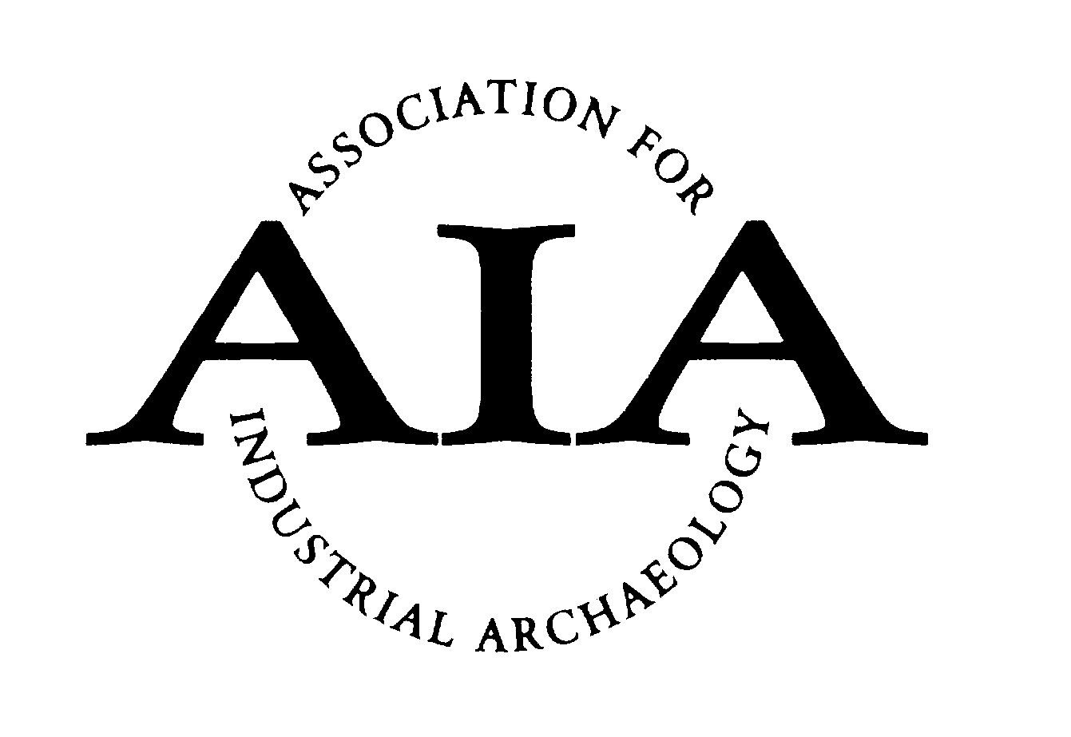
Name of organisation (client / developer):
Organisation type: (please tick relevant box)
Not for profit – voluntary sector (registered charity, community interest company etc)
Not for profit – public sector (e.g. local authority)
Private sector
Contact name, address, telephone number and email address:

Name and address of project property:

Statutory designations (listed, SAM, conservation area):

Local Planning Authority and planning history
Please provide the reference numbers of any planning applications and / or listed building consent applications relating to your project, and the name of the planning authority:

Date project started:

Date project was completed (practical completion):

Design team:
Please provide the company name and website address for each design team member (e.g. architect, structural engineer, archaeologist, quantity surveyor etc)

Building contractor:
Please provide the company name and website address (where available)

Total project cost and funding (capital works & fees only):

Project description (max 100 words):

Building use(s) before the project (if vacant before, how long for?):

Was the property ‘at risk’ before the project commenced? (national or local ‘at risk’ register?) Describe the building condition before works commenced (say, 50 words) Please provide a small selection of ‘before’ images either embedded in the text or attached to your application, with appropriate file names. (But note that emails must not exceed 9MB, so convert your Word document to a PDF before emailing)

Describe how the project meets the AIA award criteria (say up to 50 words for each). Please provide images to illustrate where appropriate, either embedded in the text or attached to your application, with appropriate file names. (But note that emails must not exceed 9MB, so convert your Word document to a PDF before emailing)
- What is the new use of the building? How will it be viable in the long term?

- How have alterations or any new build elements been incorporated or added?

- How can the original building, its function and any processes that used to go on within it be ‘read’ in the architecture today? How has the original layout been retained or illustrated?

- What interpretation has been provided to help the understanding of the building where the original function is not self-evident?

- Describe any features of the building’s industrial past that survive today, such as mechanical plant, kilns, chimneys, or internal features like fire proofing or evidence of the power train.

- Describe the external landscape around the building and how this relates to the original industrial function of the site, if at all.

- What is the future maintenance strategy for the project and how will this be funded?

- How has the project been designed to take into account issues of climate change? Describe any energy efficiency measures, including the choice of materials, water management, fuel options and facilities for recycling of waste.

Is there anything else we should know about the project or its delivery?

