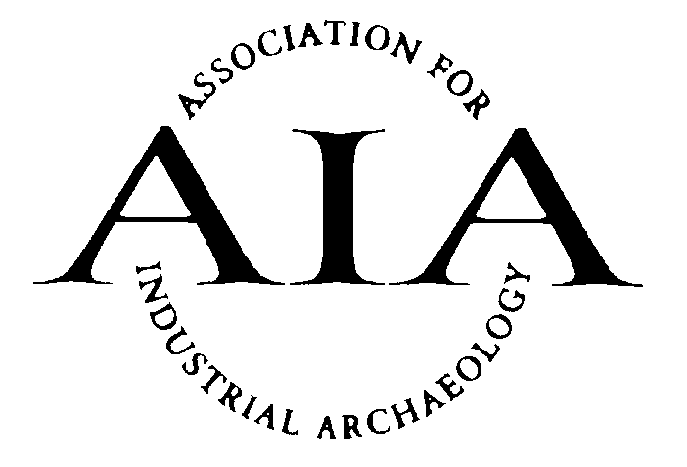
Association for Industrial Archaeology

Peter Neaverson Award for Outstanding Scholarship

- The award will be given to the author(s) of the work which, in the opinion of the judges, has, in the year in question, made the greatest contribution to the advancement of the discipline of industrial archaeology, for example in developing new methodologies, providing new insights or demonstrating outstanding scholarship.

- Any work published in English anywhere in the world is eligible for consideration, whether it be a paper, article, book or published thesis, normally within two years of publication. The judges may extend this two-year period if circumstances have delayed the nomination, for example in the case of books not published in the UK.

- Nominations for works to be considered for the award can be made by any member of the AIA and its Affiliated Societies. They must be made on the relevant nomination form and reach the AIA Liaison Officer by January 31st for consideration for that year’s award.

- Should the judges consider that a nomination does not meet the criteria for this award, the AIA reserves the right to submit it for one of its other awards.

- Three judges for the award will be appointed by AIA Council; one of these will be an editor of Industrial Archaeology Review. A simple majority is required for their decisions.

- No person who has written, or made a significant contribution to, a particular work can nominate or judge it.

- In the event that two equally-outstanding nominations are received in any year, the judges may make two awards. However, should the judges consider that no nominations in a particular year meet the required criteria, no award will be made.

- The prize will be a cash award of £500, together with a certificate. Winners (up to a maximum of two) are also entitled to one year’s free membership of AIA.

- The winner(s) will be invited to the AIA’s Annual Conference to receive the award, and to speak about their work. Details of winning entries will be published in IA News and a list of all winners will be maintained on the AIA web site.
Peter Neaverson Award for Outstanding Scholarship

Nomination Form

Please read the rules for this award before making a nomination. Nominations must reach the AIA Hon Secretary by 31st January for consideration for that year’s award, sent to secretary@industrial-archaeology.org or by post to David de Haan, 7 St Michael’s Close, Madeley, Telford, Shropshire TF7 5SD.

Name: ............................................................................................................

Address: ...........................................................................................................

...........................................................................................................

e-mail: ...........................................................................................................

Telephone: ...........................................................................................................

Signature ........................................... Date: ....................................................

Details of nominated work

Title: ...........................................................................................................

Author : ...........................................................................................................

Publisher: ...........................................................................................................

Publication date: ................................................................................................

Reason for nomination (continue on a separate sheet if necessary):

.................................................................................................................................

.................................................................................................................................

.................................................................................................................................

.................................................................................................................................

.................................................................................................................................

.................................................................................................................................

