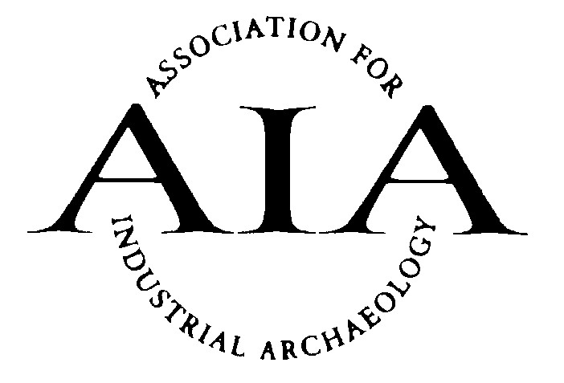
Gift Aid Declaration

In order to Gift Aid your donation you must tick the box below:
I want to Gift Aid my donation of £______________ and any donations I make in the future or have made in the past 4 years to:
Association for Industrial Archaeology

I am a UK taxpayer and understand that if I pay less Income Tax and/or Capital Gains Tax than the amount of Gift Aid claimed on all my donations in that tax year it is my responsibility to pay any difference.

My Details

Title ____________________ First name or initial(s) ________________________________

Surname _______________________________________________________________________

Full Home address _______________________________________________________________

______________________________________________________________________________

______________________________________________________________________________

Postcode __________________________ Date ___________________________________

Please notify the Treasurer if you:
- want to cancel this declaration
- change your name or home address
- no longer pay sufficient tax on your income and/or capital gains

If you pay Income Tax at the higher or additional rate and want to receive the additional tax relief due to you, you must include all your Gift Aid donations on your Self-Assessment tax return or ask HM Revenue and Customs to adjust your tax code.

When completed please return this form to:
AIA Treasurer, John Jones, by post to Hines Farm, Earl Stonham, Stowmarket, Suffolk, IP14 5HQ, or a scanned image, to treasurer@industrial-archaeology.org.
If you are joining the AIA this form may be sent with your application form.

Revised October 2020

